**Issue 12:** The alignment of the MI field is not correct

**Description:** The MI field can be moved to a little left; to make the UI more aligned

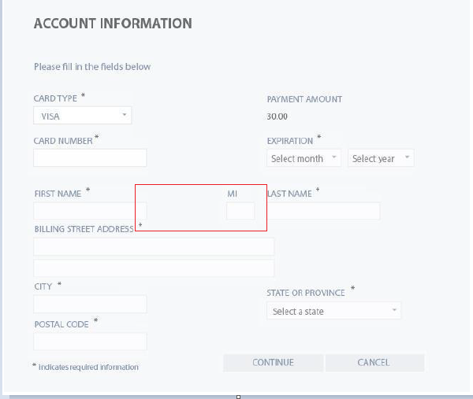

**Expected Behavior**: The MI field should be moved to a little left to make the UI more aligned

**Severity**: Cosmetic